**UNIVERSITY OF VICTORIA**

Department of Electrical and Computer Engineering

**ELEC 360 – Control Systems I**

**Laboratory 3**

**Experiment no.:** 2

**Title:** Modeling and Identification of a DC Motor

**Date of Experiment:** November 7, 2017

**Report Submitted on:** November, 14, 2017

**To:** Akash Panchal

**Laboratory Group No.:** Group 35

**Names:** David Li V00818631 Mike Viala V00850502

## Summary

Designing Proportional Integral (PI) controller requires understanding of qualitative properties of proportional and integral controllers, determining values of external parameters such as (kp and ki) given PI specifications, and measuring the response of the system to load disturbances [1].

## Introduction

## Experimental Results

### 5.1.1 Proportional Control

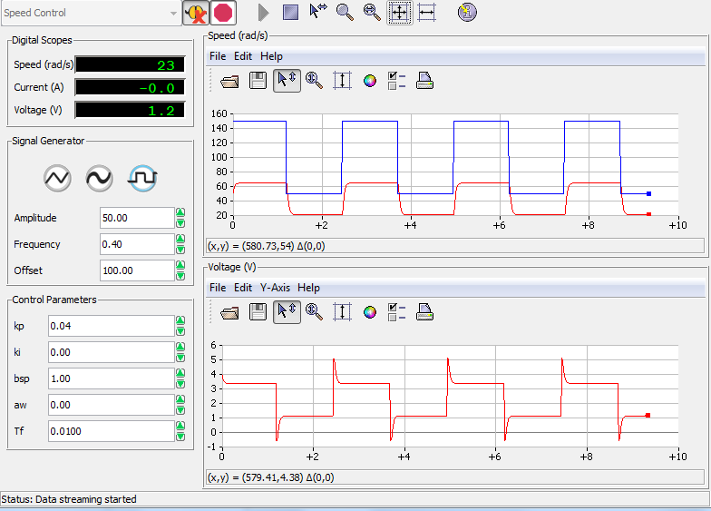

Starting values for proportional control

*Step 2: kp* from 0.1 V s/rad to 0.4 V s/rad, ki = 0

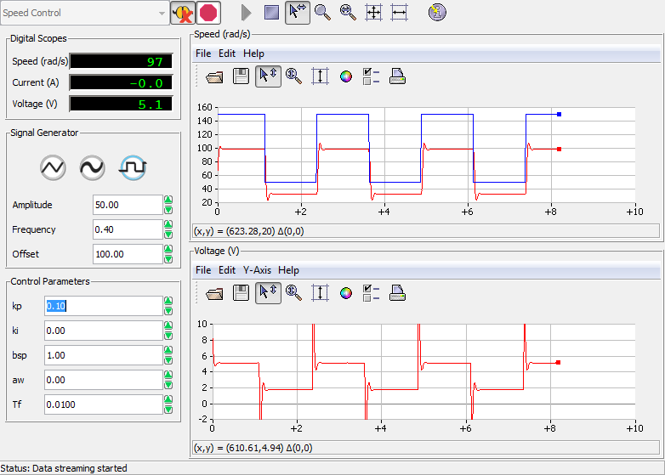

Kp = 0.1 V s / rad

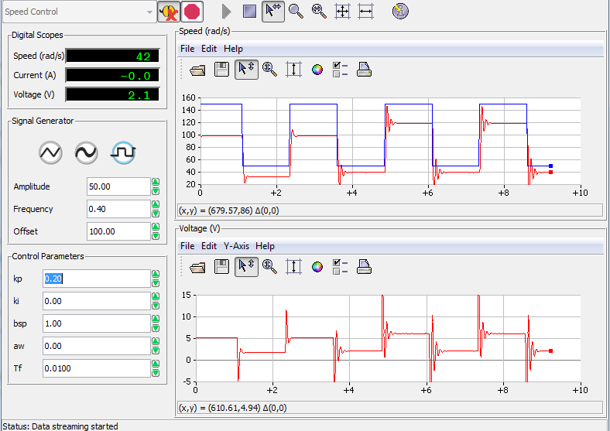

Kp = 0.2 V s /rad

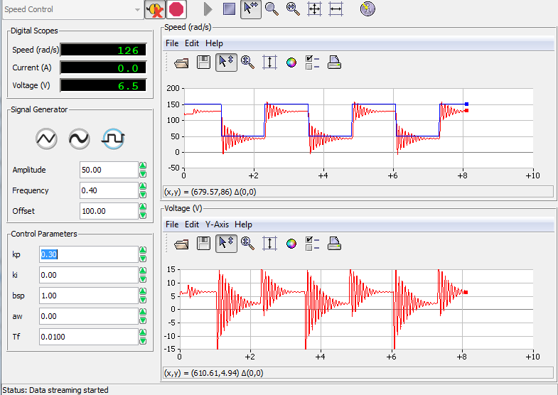

Kp = 0.3 V s /rad

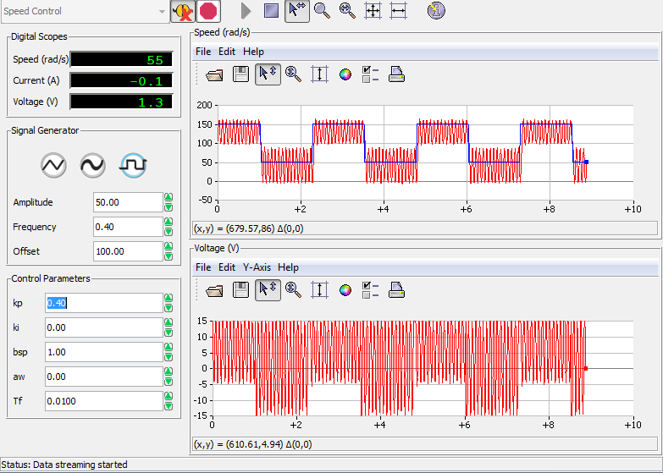

Kp = 0.4 V s /rad

Step 3 Observe and describe the steady-state error to a step input, as *kp* is increased

It decreased steady state

Step 4 Summarize your observations in your report and include some representative results, screen captures, and plots. Discuss how your plots compare with the analysis in 4.1.

Do later

### 5.1.2. Integral Control

Step 1 Set the proportional gain to zero. Set the integral gain to 0.4 V/rad to start with. Ensure that the parameters are set as listed in Table 2.5.

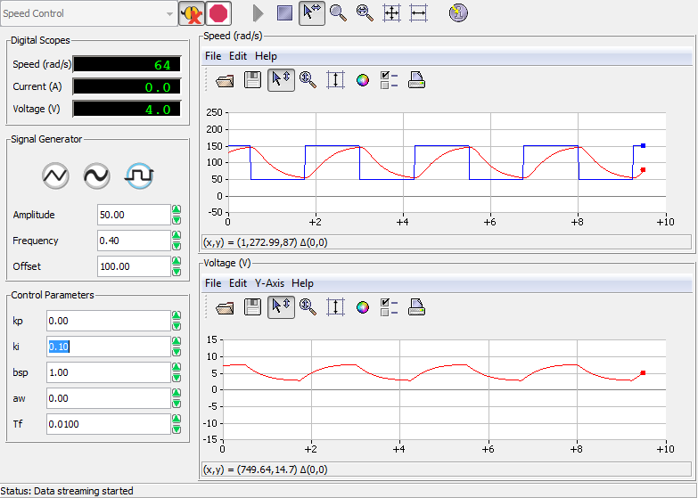

Ki = 0.1 V /rad

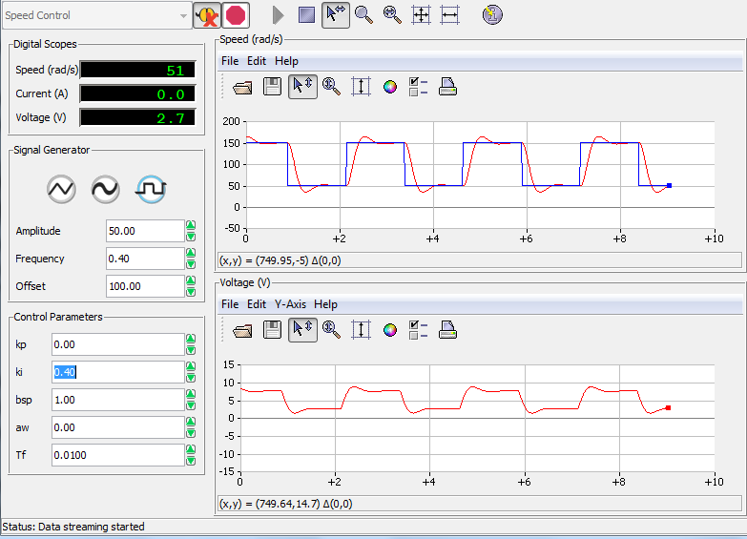

Ki = 0.4 V/rad

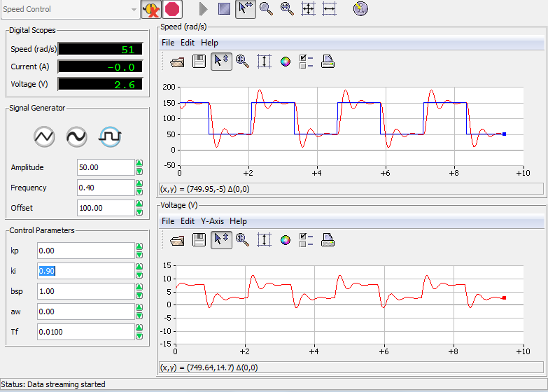

Ki = 0.9 V rad

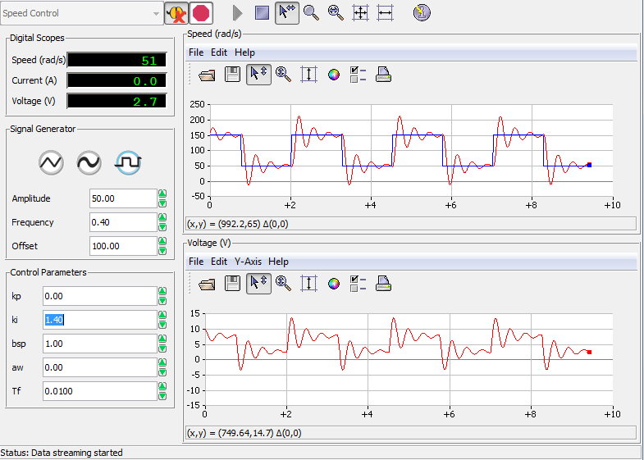

ki = 1.4 V /rad

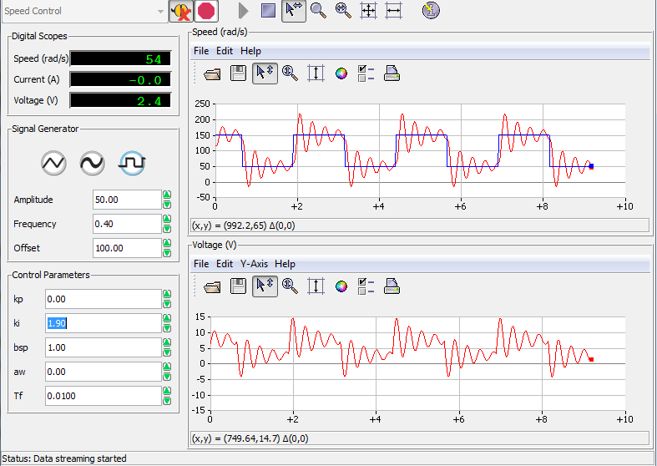

Ki = 1.9 V /rad

Step 3 Determine a value of integral gain which gives the quickest response without overshooting. Determine the settling time for this closed loop system.

Ki should be about 0.16, and has no overshoot

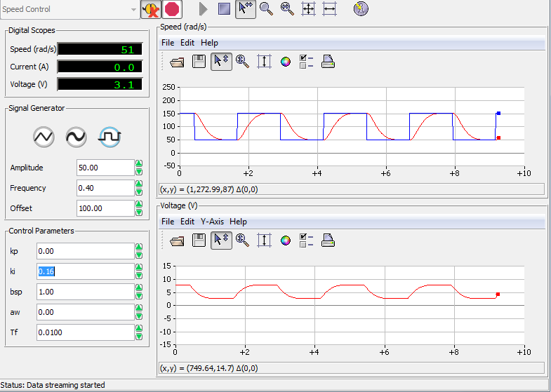

Step 4 Summarize your observations in your report. Select some representative results, screen captures, and plots. Discuss how your plots compare with the analysis in 4.2.

Do later

### 5.1.3. Proportional and Integral Control

The combination of proportional and integral control will now be explored. Please follow the steps below.

Step 1. Set the parameters as listed in Table 2.6.

|  |  |  |  |
| --- | --- | --- | --- |
| ***Signal Type*** | ***Amplitude* [rad/s]** | ***Frequency* [Hz]** | ***Offset* [rad/s*]*** |
| Square Wave | 50 | 0.4 | 100 |

Step 2. Set *bsp* = 1, proportional gain to *kp* = 0.1 V s/rad, and change integral gain *ki* in the range of 0.5 to 5 V/rad. Observe the tracking error (difference between input and output signals) and the control signal.

Kp is constant

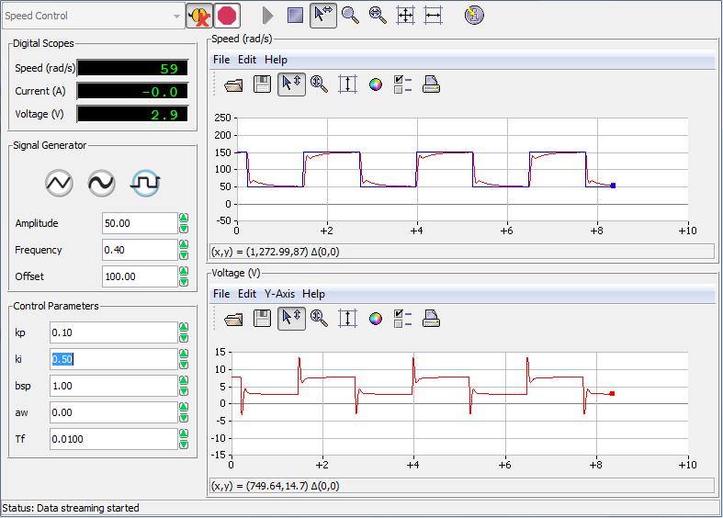

Ki = 0.50 V /rad

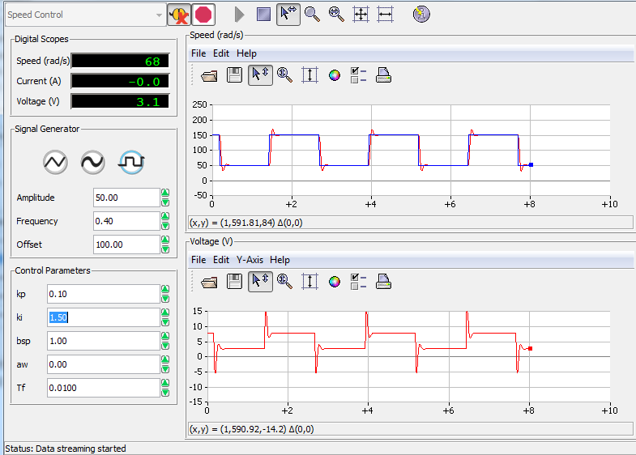

Ki = 1.5 V/rad

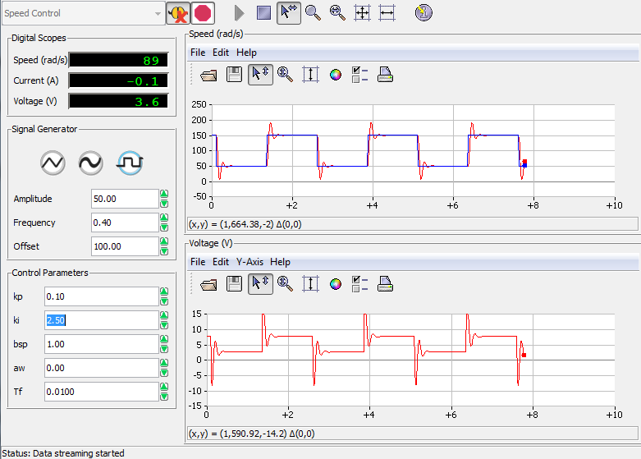

Ki = 2.5 V/rad

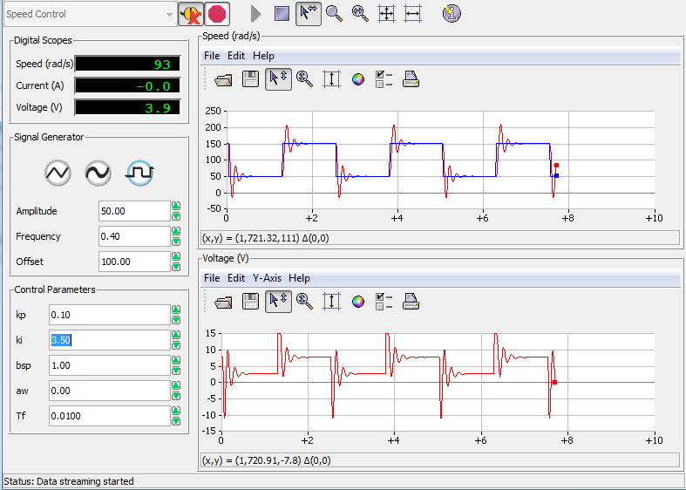

Ki = 3.50 V / rad

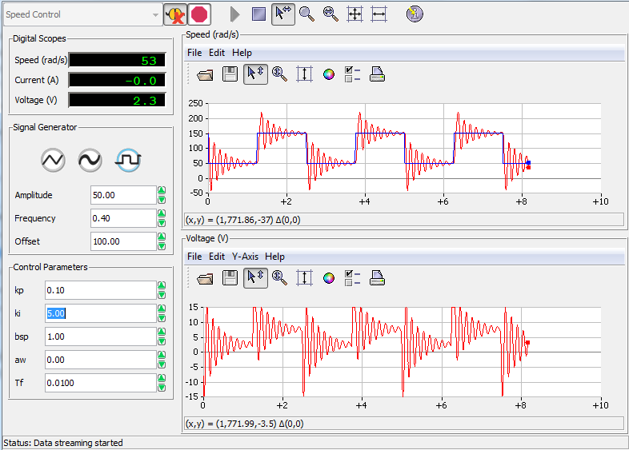

Ki = 5 V /rad

Step 3. Set integral gain to *ki* = 0.5 V/rad, *bsp* = 1 and change proportional gain *kp* in the range of 0.05 to 0.3 V s/rad. Observe the tracking error and the control signal.

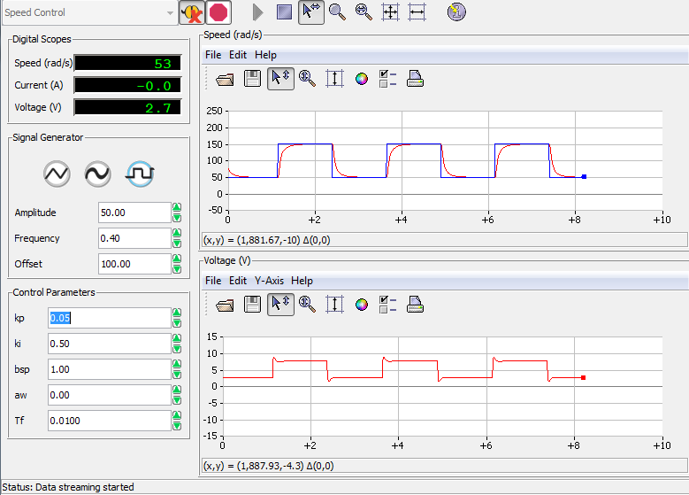

Kp = 0.05 Vs /rad

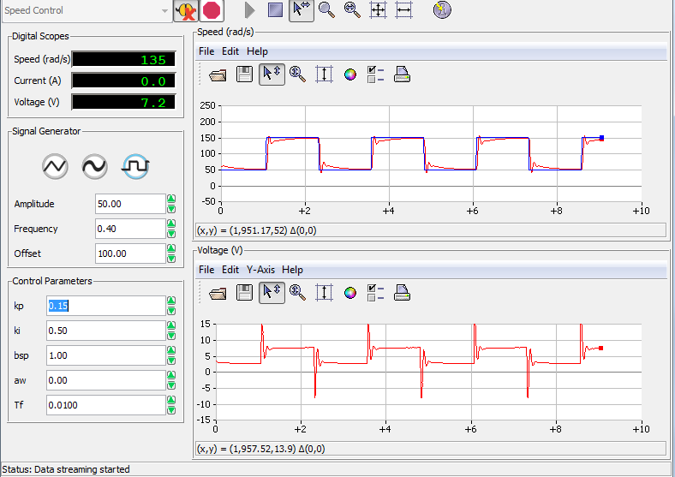

Kp = 0.15 Vs /rad

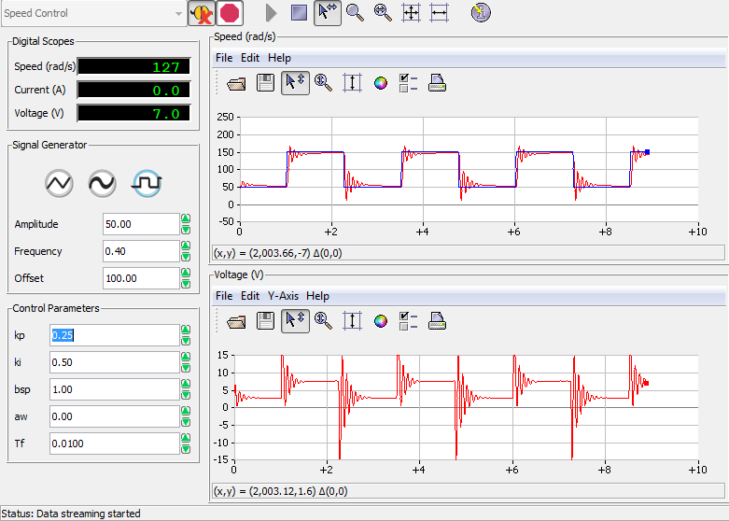

Kp = 0.25 V s /rad

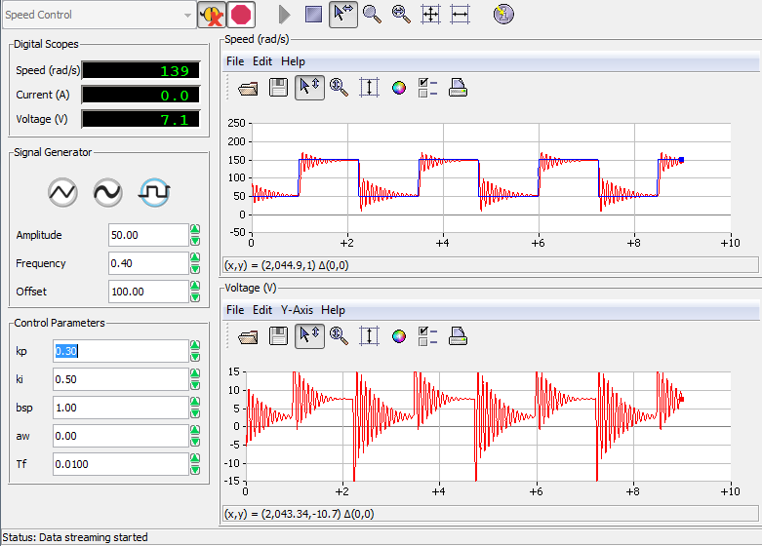

Kp = 0.30 Vs /rad

Step 4. Set *bsp*, the proportional and integral gains to the values obtained in section 4.3.3. Observe the tracking error and the control signal.

|  |  |  |
| --- | --- | --- |
| =1 | = 0.10 Vs /rad | =1.20 V /rad |

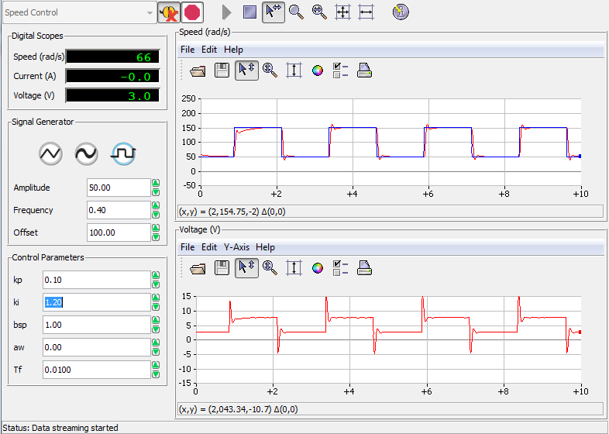

Step 5. Summarize your observations in your report. Select some representative results, screen captures, and plots. Discuss how your plots compare with the analysis in 4.3.

Do later

### 5.2. Close-loop System’s Response to Disturbances

Step 1. The response to disturbance *Td* at a constant reference speed of 150 rad/s, is investigated. Set the signal generator module parameters to 0 [rad/s] Amplitude and 150 [rad/s] Offset.

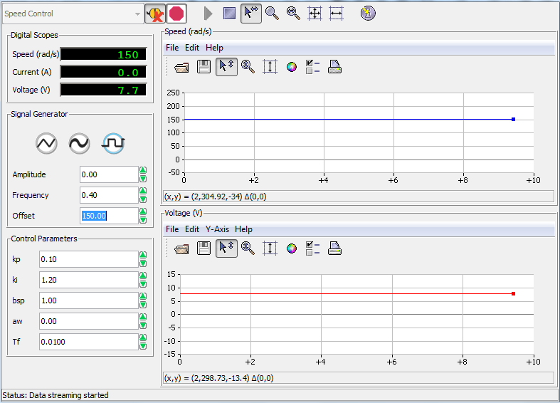

Setting the Amplitude to 0 rad /s

Step 2. Choose a pure proportional controller (*ki* = 0, *bsp* = 1) with gain *kp* = 0.20 Vs/rad. Apply a torque manually by gently touching the inertial load with your finger. Observe what happens when you change the gain of the controller.

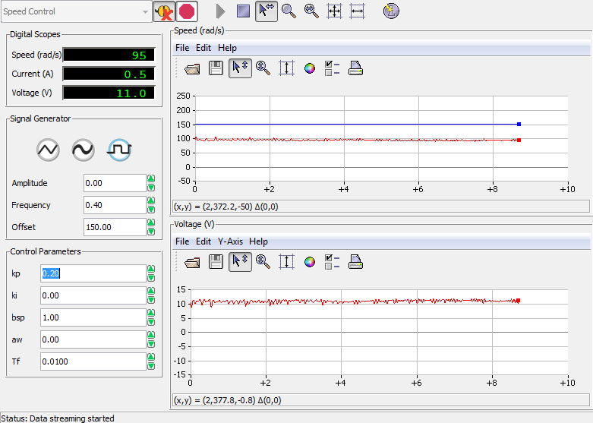

Applying load with finger when

Figure X : Gently touched motor with finger

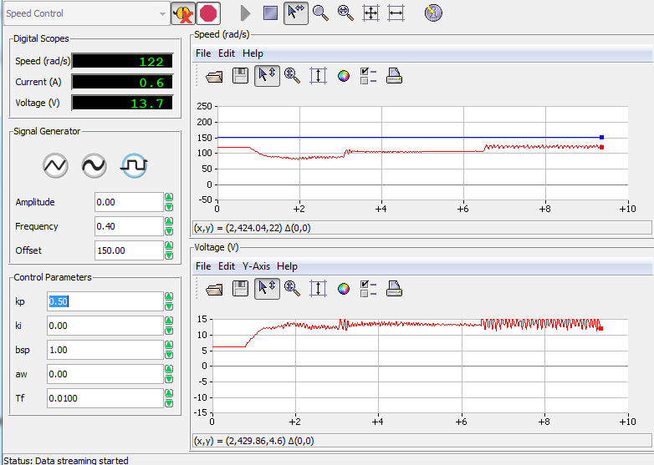

Applying load with finger when

Step 3. Choose a controller with pure integral action (*kp* = 0), such that ki = 1.0 V/rad. Apply a disturbance torque manually and observe what happens.

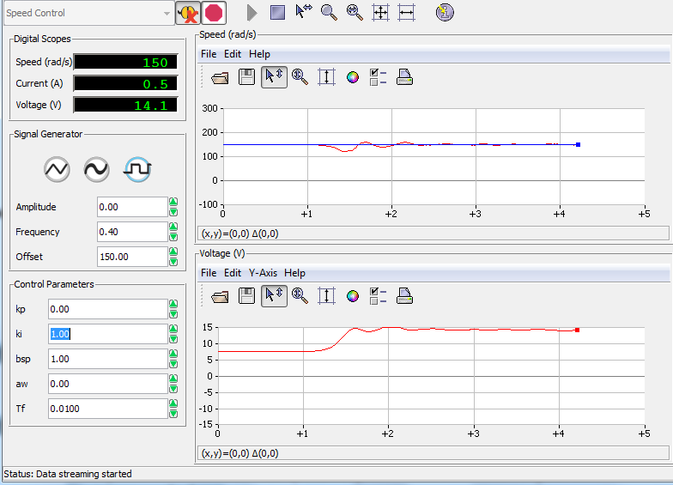

Applying load with finger when

Applying disturbance manually

Step 4. Observe the response of the system output w*m* to the external disturbance when using proportional control and when using integral control. Summarize your observations and your calculations in your report. Select some representative results, screen captures, and plots.

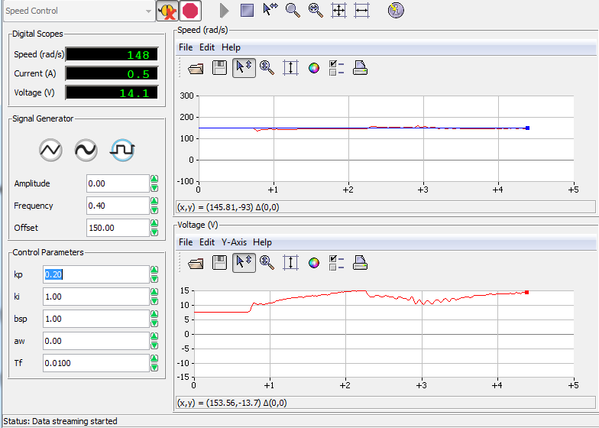

Applying load with finger when

Disturbance applied when using integral and proportional controller

### 5.3. Manual Tuning of PI Controller: Ziegler-Nichols

This part of the experiment should illustrate the performance of the closed-loop system with a manually tuned PI controller and compare its performance with the previous controllers.

Please follow the steps below.

Step 1. Determine the critical gain, *kpc*, (*ki* = 0, *bsp* = 1) where the system becomes critically stable and a stable oscillation is achieved. Also determine the critical period *Tpc* of the corresponding oscillations (Refer to section 3.1 for procedures). Using these values determine the Ziegler-Nichols controller gains using the equations in 3.1.

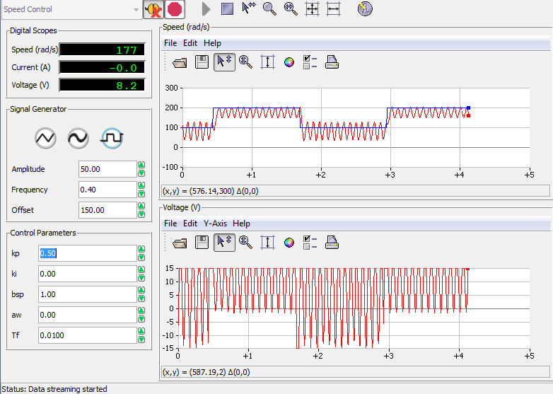

Finding the value for critical gain, , manually.

Finding a critical value for kp manually.

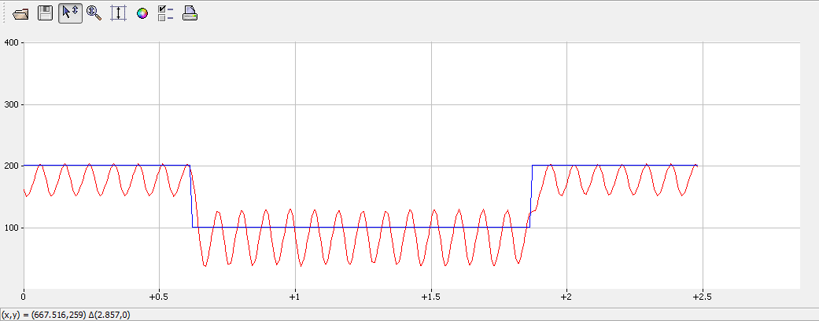

Estimating the corresponding period,

Finding the period for Tpc

|  |  |  |  |
| --- | --- | --- | --- |
| Description | Symbol | In-Lab Result | Units |
| Properties of PI Control |  |  |  |
| Critical proportional gain |  | 0.5 | Vs/rad |
| Critical period for kpc |  | 0.9 | s |
| Ziegler-Nichols design |  |  |  |
| Proportional gain |  | 0.2 | Vs/rad |
| Integral gain |  | 0.278 | V/rad |

*kp* = 0.4 *kpc*

*Ti* = 0.8 *Tpc*

*ki* = *kp* / *Ti* or *ki* = 0.5 * *kpc* / *Tpc*

Step 2. Set the parameters of the signal generator module window as listed in Table 2.7.

|  |  |  |  |
| --- | --- | --- | --- |
| ***Signal Type*** | ***Amplitude* [rad/s]** | ***Frequency* [Hz]** | ***Offset* [rad/s]** |
| Square Wave | 50 | 0.5 | 150 |

**Table 2.7.** Module parameters for the Ziegler-Nichols-tuned PI controller

Set *bsp* = 1, both proportional and integral gains to their Ziegler-Nichols values as calculated. above. What are your observations?

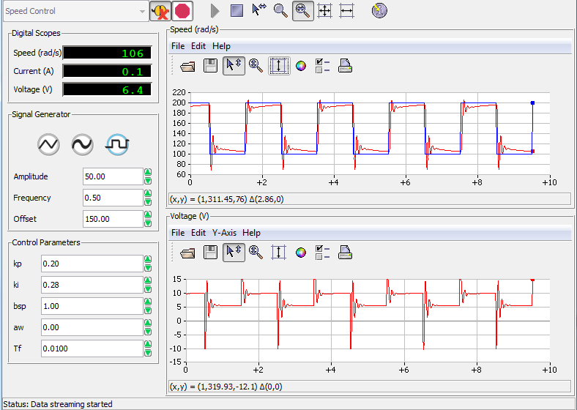

Using the set values of and

Figure X: Inputting values of Ziegler- Nichols Tuning

Step 3. Adjust proportional and integral gain manually to give a very slightly under-damped response with no saturation of the control signal (the system is saturated when changing the control signal does not have any effect on the output signal). Comment on the new gain values.

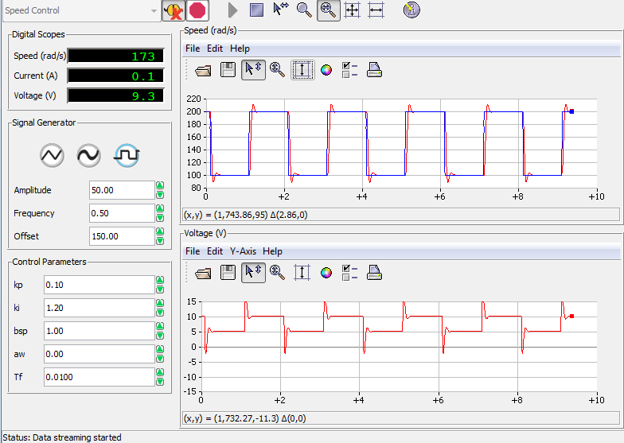

Manually adjusted values until slightly underdamped response is reached.

Figure X: manually tuning

Kp = 0.10 Vs /rad

Ki= 1.20 V /rad

Step 4. How does the response of the gain values of the Ziegler-Nichols compare with the previous controllers in 5.1.1, 5.1.2. and 5.1.3.? Explain your observations.

Step 5. Summarize your observations and your calculations in your report. Select some representative results, screen captures, and plots.

## Discussion

## Conclusion

## References

[1] Dr. P. Agathoklis et al. 2016. Laboratory Manual for ELEC 360 Control Systems I. University of Victoria, Canada.